THE OTER

V

We respectfully acknowledge that we are on the traditional land of the Yakama People.
This Newsletter published by and for the
League of Women Voters of Yakima County
PO Box 723 Yakima WA 98907 509-452-3419
October, 2020
Vol.20, No 10

CALENDAR

Wednesday, October 14, 7:00PM EmpowHer Program. Heritage University Webinar. See article and flyer.

Friday, October 16 Ballots Mailed to Registered Voters – PLAN YOUR VOTE! See articles.

Monday, October 19 Get Out the Vote Calling Begins.
See article.

Tuesday, October 27, 5:30 to 7:00 PM League Conversation: Crisis Responders Partner With Police.Via Zoom; link will be sent by email. See article.

Monday, November 2, 4:30 PM Leadership Team Meeting. Via Zoom.

Tuesday, November 3. ELECTION DAY!

MISSION STATEMENT
Empowering Voters. Defending Democracy.

VISION
We envision a democracy
where every person has the desire,
the right, the knowledge, and the confidence
to participate.

VALUE STATEMENT
The League believes in the power of women to create a more perfect democracy.

March 26

April1, 4 PM

Officers
President: Criss Bardill
Secretary: Karen Pilon
Treasurer: Janis Luvaas

Leadership Team
Quinn Dalan
Rhona Hauff
(also Membership)
Kitty Jubran
Susan Kaphammer
Cheri Kilty
Kathy Lambert
Anita Monoian
Lee Murdock

Voter Editor: Susan Kaphammer
949-0127; susanlkap@gmail.com

The Board currently meets at 4:30 PM
the 1st Monday of each month via Zoom.
All members are welcome.
Contact Criss Bardill at 509-965-2351 or at cbardill@gmail.com to “attend”

LWVYC President’s Column…

NOTES FROM CRISS

As I write this, we are preparing for our County Commissioner Forum on Zoom this evening. I will be grateful in the next election season to hopefully be presenting our forums live, and not on Zoom. It has been a big learning curve! I want to give my thanks to Susan Kaphammer; we have been a good team in large part because of her expertise and excellent ideas. Quinn Dalan is helping with the process of “streaming” the forum live to our Facebook page, and Delores Irwin from the Kittitas County LWV is volunteering as our timer. All the Zoom experts at Kittitas LWV have helped greatly. Last but not least, Amy Peloff, the Administrative Director at the State League office, has been invaluable. It takes a village to do a Zoom Forum!
Continued on Page 2

Continued on Page 2

Page 2

co

The Voter, October, 2020 Page 2

NOTES FROM CRISS Continued from Page 1

We have ordered our Get Out the Vote (GOTV) calling lists from Win / Win Washington, and plan to start our calling on Monday, October 19. We have developed scripts and we have multiple non-League volunteers from the community who are going to be helping. It’s not too late to volunteer, and you will control how many calls you want to make. Calls should be quick, as we are not eliciting any opinions, just encouraging folks to vote! Please let me know if you want to be added to our caller list.
I am feeling that the next few weeks are going to be stressful for most of us as we watch this extraordinary and norm busting election take place and whatever the aftermath may be. I am grateful for Washington State’s deep experience with mail-in balloting and the conscientious and trustworthy election management in the Auditors’ offices across our state. I wish it were the norm across the country.
And as we all grow weary of masks and social distancing, please stay strong in your self-protection and the protection of those around you. Someday, this really will be behind us.
– Criss Bardill

October League Conversation. . .

CRISIS RESPONDERS PARTNER WITH POLICE

Tune in to our League Conversation via Zoom on Tuesday, October 27, at 7:00 PM. Designated crisis responders, known as DCRs, accompany law enforcement officers, including Yakima police. Associated with Comprehensive Healthcare, these mental health professionals assist and supplement police when they respond to individuals who may be experiencing a mental health crisis. Anecdotal, hands-on information as well as data about the DCR program is slated for our Conversation.
Watch your email for the Zoom link.

LWVYC Member on State Commission. . .
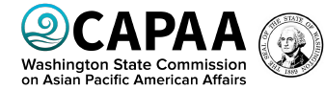
CARRIE HUIE-PASCUE PROVIDES VOICE FOR COMMUNITY

Local League member Carrie Huie-Pascue serves as one of twelve citizens appointed by the Governor to the Washington State Commission on Asian Pacific American Affairs (CAPAA). The Commission works to improve the lives of members of the diverse Asian Pacific American communities in our state by ensuring access in the fields of government, business, education, and other areas.
A first-generation Chinese American born in Ellensburg, Carrie graduated from Central Washington University with a B.A. and a M.S. from San Francisco State University in Clinical Psychology. She has over 35 years of experience serving people with behavioral health needs. As director of behavioral health agencies in Washington and California, Carrie has focused on developing programs that provide culturally and linguistically appropriate services.
Carrie Huie-Pascue’s work with CAPAA is just the latest of her service on boards and committees dealing with issues of equitable access in social services. She is active in the Filipino American Community of the Yakima Valley.

The Voter, October, 2020 Page 3

LWVYC Partnering on Event. . .

Plan to listen on Wednesday, October 14, at 7:00 PM to a discussion by women leaders – including local League member, Quinn Dalan – as they explore how women can come together to affect change and build opportunities for all. Noting that women have come a long way since ratification of the 19th Amendment 100 years ago, there is still work to do to build true equality. Heritage University is hosting this event to celebrate the achievements women have made and keep up the momentum to do even more!
Register now at https://heritage.edu/empowher-2020/ to receive email confirmation of your registration which includes the Zoom webinar link.

League Activity . . .

GET OUT THE VOTE CALLING PLANNED

Members and friends of the LWVYC are getting ready to make personal phone contacts with infrequent or newly registered voters. Calling is slated to begin October 19 and can continue through the end of the month. With simple scripts to follow, callers will provide only brief, friendly reminders to vote, as well as a mention of the League Voters Guide, VOTE 411. Sample wording is also provided to maintain our non-partisan approach and to, if necessary, disengage from a contrary response.
Additional callers are welcome; let Criss Bardill know of your
interest. Agreeing to help does not commit you to a specific number
of calls; let Criss know what you feel you can do. cbardill@gmail.com

The Election Division of the Yakima County Auditor’s Office applauds our efforts to improve voter turnout. These calls to voters are a way to safely work to help fulfill our LWVYC Vision, posted on the first page of each issue of Voter, but repeated here to acknowledge our efforts toward this vision:
We envision a democracy where every person has the desire,
the right, the knowledge, and the confidence to participate.

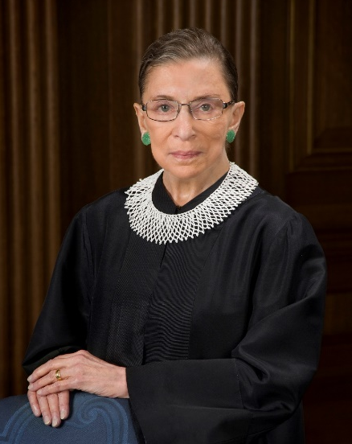
Remembering . . .

RUTH BADER GINSBURG

Upon the news of Justice Ginsburg’s death, a series of emails by LWVYC members spoke of her life, her work and her inspiration. A sampling of the messages: She calls us to action to advance our country to a higher level of justice and protection of all… She changed all of our lives and the lives of our daughters and granddaughters… We are all the better for her lifetime of intelligent compassion and her unflagging work for equal justice… Action, and being alert, is sorely needed after such a tremendous loss… Now it’s up to us to MULTIPLY her good work.

The Voter, October, 2020 Page 4

Empowering Voters. Defending Democracy. . .

PLAN YOUR VOTE!

NOW – Check registration status; learn about the candidates and understand the issue.
VoteWA provides personalized information including registration status, voter guide with candidate statements and issue analysis, locations and maps to ballot boxes at
https://voter.votewa.gov/WhereToVote.aspx

Voter’s Pamphlet available in multiple languages and formats (including audio file) at https://www.sos.wa.gov/elections/voters-guide/2020/2020-general-election-voters-guide.aspx

Click here for Spanish language version.

VOTE411 is League of Women Voters site with link to register, voter guides with candidate statements plus answers to questions and other helpful information at https://www.vote411. org/

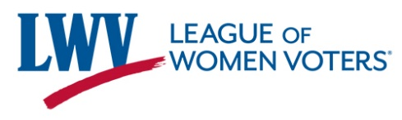
Debates by Statewide Candidates are available to view on https://lwvwa.org/Forums. View the Yakima County Commissioner Position 1 Candidates debate on the LWVYC Facebook page at https://www.facebook.com/LWVYC/ posts/1526656527532973
WHEN BALLOT ARRIVES around October 16 – Mark your ballot by following instructions carefully and clearly. You may choose not to vote on all measures or offices.

Place marked ballot in security envelope or sleeve.
Put security envelope or sleeve into return envelope.
Sign the envelope with your name as shown on the mailing of ballot you received, i.e. your name as used to register.

RETURN YOUR BALLOT ON TIME – SOONER IS BETTER! Options:
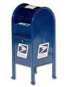
Mail your ballot; no stamp needed; it must be postmarked no later than November 3.
OR
Place ballot in Election Ballot Drop Box by 8 PM on November 3.
17 boxes are located around the County. See the locations and hours available at Yakima County Election information at https://www.yakimacounty.us/1136/Where-to-return-your-ballot-and-accessib
OR
For accessible services, vote in-person at the Yakima County Courthouse Auditor’s Office,
128 N 2nd Street, Rm 117, from 9 AM to 4 PM; on November 3 from 8 AM to 8 PM deadline.

The Voter, October, 2020 Page 5

LWVWA STATEMENT ON DIVERSITY: The League of Women Voters is an organization fully committed to diversity, equity, and inclusion in principle and in practice. Diversity, equity, and inclusion are central to the organization’s current and future success in engaging all individuals, households, communities, and policy makers in creating a more perfect democracy. We will actively work to remove barriers to full participation in this organization on the basis of gender, gender identity, ethnicity, race, native or indigenous origin, age, generation, sexual orientation, culture, religion, belief system, marital status, parental status, socioeconomic status, language, accent, ability status, mental health, educational level or background, geography, nationality, work style, work experience, job role function, thinking style, personality type, physical appearance, political perspective or affiliation and/or any other characteristic that can be identified as recognizing or illustrating diversity.

LEAGUE OF WOMEN VOTERS YAKIMA COUNTY
Empowering Voters. Defending Democracy.

Name:________________________________________________________________________
Address_______________________________________________________________________

Phone Numbers:
Home___________________Work__________________Cell__________________

Email_______________________________________________
Membership Categories:

_______$60 Basic*

_______$40 Each additional family member at the same residence

_______$10 Student Associate

Sustaining Gift: $60 _____ $40 _____ $25 _____ Other:_______ Your Sustaining gift will help support our local activities.

*Please Note Dues Distribution: National: $32
Make checks payable to: LWVYC Mail to: PO Box 723
YAKIMA WA 98907

State: 19
LWVYC retains: 9
$60

