THE OTER

V
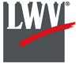

We respectfully acknowledge that we are on the traditional land of the Yakama People.
This Newsletter published by and for the
League of Women Voters of Yakima County
PO Box 723 Yakima WA 98907 509-452-3419
March, 2020
Vol.20, No 3

CALENDAR

Due to the coronavirus pandemic,
events may be postponed or cancelled.
Check for schedule updates prior to attendance.

March League Conversation. CANCELED. Program on Washington State Long Term Care Act will be rescheduled.

Sunday, March 22, 2:00-3:30 PM. Hear My Voice Performance. Yakima Valley Museum, 2105 Tieton Drive, Yakima. $5 admission. Museum website: https://www.yvmuseum.org/events.

Monday, April 6, 4:00 PM Leadership Team Meeting. League Office at Unitarian Universalist Church, 225 N 2nd Street, Yakima. Check for email in case of schedule change.

Wednesday, April 8, 12:00-1:00 PM. Humanities Washington: Is Truth Really Dead in America? Yakima Valley Museum, 2105 Tieton Drive, Yakima. Museum website: https://www.yvmuseum.org/events.

Wednesday, April 22, 12 Noon. Kara Konda Luncheon. Hilton Garden Inn, 401 E Yakima Avenue, Yakima. $25. Check for email in case of schedule change.

Looking ahead:

Wednesday, May 6, 12:00-1:00 PM. Humanities Washington: Hacking Democracy. Yakima Valley Museum, 2105 Tieton Drive, Yakima.

Monday, May 18. LWVYC Annual Meeting. Details to follow.

Weekend of May 29-31, LWV Washington State Council. Red Lion Inn, Yakima.

MISSION STATEMENT
Empowering Voters. Defending Democracy.

VISION
We envision a democracy
where every person has the desire,
the right, the knowledge, and the confidence
to participate.

VALUE STATEMENT
The League believes in the power of women to create a more perfect democracy.

March 26

April1, 4 PM

Officers
President: Criss Bardill
Secretary: Karen Pilon
Treasurer: Janis Luvaas

Board of Directors
Quinn Dalan
Cynthia Garrick
Rhonda Hauff
Kitty Jubran
Susan Kaphammer
Cheri Kilty
Kathy Lambert
Marilyn Shearer
Elaine Smith

Voter Editor: Susan Kaphammer
949-0127; susanlkap@gmail.com

The Board meets at 4:00 PM the 1st Monday of each month at the League Office at the UUCY Church, 225 N 2nd Street, Yakima
All members are welcome to attend.

Wee

The Voter, January, 2020 Page 2

co

The Voter, March, 2020 Page 2

LWVYC President’s Column…

NOTES FROM CRISS

If you are a League member, you have recently received several emails from me seeking volunteers to staff voter registration/education tables, assist with coming events that we are supporting, and work with Yakima-Yakama Census 2020 to encourage census completion among older people. I hope you give serious consideration to help with one or more of these opportunities.
To update, we have sufficient volunteers for our LWVYC table at the Yakima Valley Museum HEAR MY VOICE event on Sunday, March 22. However, I strongly urge you to attend this live performance which tells the story of Women's Suffrage through Jessie, the daughter of a political columnist growing up in Washington, DC, during the early 1900s. It has excellent reviews on line. Tickets are only $5, so it is a great opportunity to invite friends and family to join you, and to support the Museum, which is recognizing the 100th Anniversary of the 19th Amendment with several events this year.
As I write this, we still have 3 tabling slots to fill at the Harmon Center this month, where we will be providing information on the Census as well as general information on League, voter registration, and our The State We’re In, State League-published history of Washington State. Call or email me if you can fill a slot on Wed, 3/25, 10-Noon; or Fridays, 3/19 and 3/26, 9-10:30 AM.
We have set our Annual Meeting for Monday, May 18, and will meet again at the Windcrest Villa clubhouse (thanks, Becky Scholl!). The 2 person Nominating Committee (Becky and Elaine Smith) have started their work. Please keep an open mind to serving if you are called. It is fine if you are new to the League, and it is a wonderful opportunity to learn what we are all about and how we function under a Leadership Team structure.
The State League has invited local Leagues to host forums for candidates for state-wide offices in the fall. Our League has done this in the past, with great turnout, but not for several years. The State works on getting candidate commitments and dates, the local arranges location, promotion, and details of the actual event. Although we would very much like to see this happen in Yakima, our current Leadership Team is stretched pretty thin and also wants to provide some candidate forums for local races. It’s a great opportunity for our visibility in the community, but we need to have some active participation from members outside of the Leadership Team. Let me know if you have any interest or would like more information before you commit to being involved.
I’m beginning to recognize the more we do, the more we are asked to do! I think this is a function of our increased visibility as well as the quality of the events we undertake. Let’s keep our momentum going in this incredibly important election year. And please take some time to enjoy our early Spring!

LWVYC Civic Engagement…

United States Census 2020 Underway

Households should now or very soon be receiving invitations to respond online to the 2020 Census. The Yakama-Yakima el Censo Coalition has been developing plans to help insure all people in our county are counted by the 2020 Census. Dori Peralta Baker has been leading our League participation with our focus on outreach to seniors, a typically under-counted population.

The Voter, March, 2020 Page 3

UNITED STATES CENSUS 2020 UNDERWAY (Continued from page 2)

Our League members are scheduling to man a table at the Harmon Center for Mondays, Wednesdays, and Friday mornings through the end of the month. These times coincide with the availability of the Harmon Center Computer Lab where people can submit their census information. We will not be assisting with the actual computer entry, but will be handing out information, registering voters, promoting the League and encouraging participation.
Dori reports, “LWVYC will play an important role by providing census materials so they (seniors) can bring home information to their families as well as share with other friends. Having a REAL person to talk with about the census can help dissipate the anxiety and can often help a person learn more about the census and why one must be counted. As we have experienced, awareness is the first step!”
Additional volunteers can assist at the Harmon Center for these table times. Contact Dori Peralta Baker at doribaker2020@gmail.com, or by phone at 509-945-0891. Step up if you can, and, as the Census slogan says, “Count Me In!”
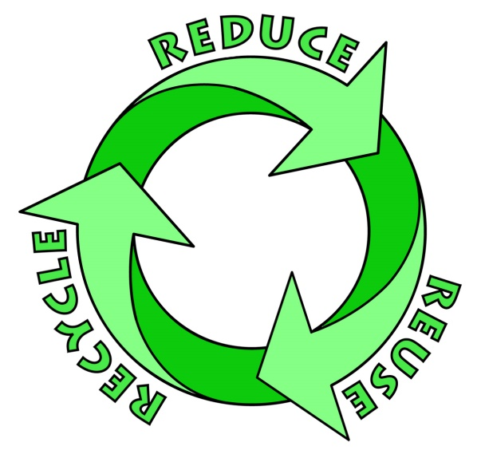

February Conversation…

RECYCLING: GLOBAL AND LOCAL

Our League’s February Conversation provided a fact-filled review of recycling efforts and issues to an audience of nearly 50 people. Her remarks were repeated and expanded upon in two articles in the Yakima Herald-Republic: “Recycling experts say reducing and reusing needs to be the new normal” in the March 9th issue, and “Are you recycling or wish-cycling? Yakima recycling volunteers share stories” in the March 10th issue. (Access these feature articles by clicking on the titles.)
The articles noted that the community conversation was “hosted by the Yakima League of Women Voters and featured Loretta Zammarchi, Yakima’s refuse and recycling manager.” While “Audience comments showed how deeply some members of the Yakima community care about their environmental footprints, and showcased the great lengths they’d go to recycle,” Zammarchi explained practical, economic realities that will push us to a “new normal” for environmentally responsible consumption.
China, which had been the largest purchaser of recycled materials, restricted then ended its role in providing a market for US recyclers. A significant factor in this change was the frequent contamination of loads by the inclusion of inappropriate materials such as food waste or plastic bags. The result of such changes in the global market is that prices received for recycled commodities have precipitously dropped, i.e. the price paid for a ton of corrugated cardboard dropped by a third between December 2017 and 2018, and the value of mixed paper dropped by over 85% that same year. Additional costs including increased sorting to improve the quality of recycle loads and transportation charges have added to the current situation where it costs more to recycle than the materials are worth Some local programs would have to absorb up to $100 or more per ton to recycle. Such economics have resulted in some “recycled” products ending up in landfills after all. The collapse of the recycling market means that city-sponsored recycling is not feasible now or in the foreseeable future as the charge to consumers would be mandatory and prohibitively high.
Continued on page 4

The Voter, March, 2020 Page 4
RECYCLING: GLOBAL AND LOCAL (Continued from page 3)

Despite the bleak economic reality, recycling is still important to society. Benefits include for the 37.4 million tons of recyclables from single-family household include reduction of greenhouse gas emissions by the equivalent of 96 million metric tons of carbon dioxide, and the conservation of energy equivalent to 154 million barrels of oil. Zammarchi notes that the “stakes are too high to ignore” with local and global issues of climate change, pollution and impacts of virgin material extraction. There is hope in moving to a new normal with a circular economy aimed at eliminating waste through changes in the design and use of materials and products. Personal and industrial efforts to “reduce and reuse” would take precedence over the impulse to “consume then recycle.”
What can we do? Encourage and support governmental, industrial and business efforts to develop package design, capital investments, policy interventions, consumer engagement and best practices by all stakeholders. And, continue to recycle.
Useful information about local recycling is available from the Yakima County website, Yakima Recycles. For curbside recycling, check out Yakima Waste Systems. Additional recycling options include Wesley United Methodist Collection Center at 14 N 48th Avenue and Central Washington Recycling at 14 N 2nd Avenue. Recycle smartly by paying close attention to what items are accepted through which service and making sure items are clean and dry. We can all do our part.

New Member to LWVYC…

BARBARA HERSEY PLANS TO CONTINUE CIVIC ADVOCACY

Barbara Hersey was the business manager for a large massage cooperative in Seattle for many years and most recently the office manager for Seattle Steam Company. She retired in 2018 and moved to Yakima last year to be closer to two of her sisters. Before the move, she embarked on a cross-country road trip where she visited Seneca Falls (home of the first women’s suffrage convention) and civil rights memorials in Cincinnati, Montgomery and Memphis.
Originally from Wenatchee, Barbara’s family moved to Yakima in 1964, where she attended St. Joseph Academy, graduating in 1967. She earned a degree in Economics from UW. Barbara lived in Yakima in the ‘80’s where she worked in social services and was partner in a small business in Selah.
Barbara has been active politically since her college days. In 1987, she carried the Washington State banner in the March on Washington for LBGTQ rights, and in 2012 she travelled to Olympia to witness Gov. Gregoire sign legislation legalizing gay marriage. She believes strongly in the work of the League of Women Voters and looks forward to working on voter registration and efforts to protect voter rights.

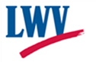
League of Women Voters of Yakima County
Cordially invites you to: JOIN US! Date:_______________

Name:______________________________________________________________

Address:____________________________________________________________________________

Phone:____________________________ E-Mail: ___________________________________________

Membership: ______$60 Basic______$40 Each additional family member at same residence
Sustaining Gift: $60 _____ $40 _____ $25____ Other_______
Make checks payable to:
LWVYC
PO Box 723
YAKIMA WA 98907
Your Sustaining gift will help support our local activities.
* Annual Dues Distribution: National - $32; State - $19; Local - $9

