THE OTER

V

This Newsletter published by and for the
League of Women Voters of Yakima County
PO Box 723, Yakima, WA 98907 509-452-3419
We respectfully acknowledge that we are on the traditional land of the Yakama People.
December, 2020
Vol.20, No 12

CALENDAR

Monday, January 4, 4:30 PM Leadership Team Meeting. Via Zoom.

Tuesday, 26, 5:30 PM League Conversation. Via Zoom. Watch for information about speaker and topic!

MISSION STATEMENT
Empowering Voters. Defending Democracy.

VISION
We envision a democracy
where every person has the desire,
the right, the knowledge, and the confi2ence
to participate.

VALUE STATEMENT
The League believes in the power of women to create a more perfect democracy.

March 26

April1, 4 PM

LWVYC President’s Column…

NOTES FROM CRISS

When I wrote this column for the November Voter, I started with the statement “As I write this the outcome of the Presidential Election is settled and we are looking forward to our continued work.” Who knew we would spend the next 4 weeks in turmoil and anxiety as we watched the challenges to the integrity of our election and the manipulations in the service of trying to overturn the results. And it is ongoing, although the courts have given me confidence our president-elect will be duly sworn in on January 20. The LWVUS has issued several statements and calls to action in support of our democratic election processes and the transfer of power. I am proud to be a part of an organization so clearly and truly committed to Empowering Voters and Defending Democracy.
Member Dori Peralta Baker attended the Train the Trainer sessions last week in preparation for facilitating the Speak-Up Schools which will prepare volunteers for testifying to the WA State Redistricting Commission in 2021. We have been in touch with Kittitas Valley LWV and may co-sponsor a Speak-Up School or Schools for Central Washington. Thank you, Dori, for your commitment and support of this endeavor. See article below.
At the December meeting, the Leadership Team agreed we would establish a PayPal account for the
Continued on Page 2

Continued on Page 2

Officers
President: Criss Bardill
Secretary: Karen Pilon
Treasurer: Janis Luvaas

Leadership Team
Quinn Dalan
Rhona Hauff
(also Membership)
Kitty Jubran
Susan Kaphammer
Cheri Kilty
Kathy Lambert
Anita Monoian
Lee Murdock

Voter Editor: Susan Kaphammer
949-0127; susanlkap@gmail.com

The Board currently meets at 4:30 PM
the 1st Monday of each month via Zoom.
All members are welcome.
Contact Criss Bardill at 509-965-2351 or at cbardill@gmail.com to “attend”

Page 2

co

The Voter, October, 2020 Page 2

The Voter, December, 2020 Page 2

NOTES FROM CRISS Continued from Page 1

Yakima County LWV which will provide an additional way to receive donations and membership fees. You will see a PayPal option on our Facebook page and in The Voter by the beginning of 2021.
It has been a quiet time since the election for local League work, and I have appreciated the conclusion of our GOTV activities and the time to enjoy some of the pleasures of the Season. Like so many, my husband and I had a quiet Thanksgiving with just the two of us, and we plan the same for Christmas. It is important, especially now with our virus numbers climbing so alarmingly, that we commit to staying safe and practicing the protocols of masks, hand washing, distancing, and staying home as much as possible. There is sadness in this reality, but it comes nowhere near the sadness that we would feel with the threat of the loss of loved ones or the experience of the virus ourselves. So I wish you a caring, loving and safe Holiday Season.
– Criss Bardill

State and Local Leagues…

PLANS BEING MADE FOR SPEAK UP SCHOOL

Expect to be hearing more about Speak-Up Schools, local League events preparing individuals to testify before the Washington State Redistricting Commission. Last month’s issue of The Voter included an article outlining the redistricting process and its importance for a working democracy.
Our member, Dori Peralta Baker, participated in Train the Trainer sessions provided by the League of Women Voters of Washington. She learned strategies to involve citizens in redistricting. Dori reports the training was “extensive and excellent.” She was pleased to witness materials from advocates from our area, Patsy Whitefoot and Mathew Tomaskin, highlighted as good examples of testimony. Dori will be presenting to our Leadership Team next month further information from her training and details about implementing Speak Up Schools.
The LWVYC is in conversation with the Kittitas Valley League about combining efforts. We also expect to partner with the Asian Pacific Islander Coalition (APIC-YKM) and perhaps other local or regional organizations to encourage diverse input for redistricting in our state.

STATE LEAGUE SEEKS MEMBERS INTERESTED IN STATE BOARD

The State League Nominating Committee has reached out to us for names of members who might be interested in discussing a possible nomination to the State Board. In addition to six officers, there are six Director positions. Of these twelve, nine are from Westside Leagues. It would be good to increase geographically diverse representation.
The State League recognizes that expecting Board members to travel to the Westside for Board meetings is not realistic. As we have all come to experience the efficiency and ease of meeting online, that issue should not be a deterrence.
If you would like to explore being involved at the State level, please let Criss know.

The Voter, December, 2020 Page 3

Spotlight on New Members…

VERNITA ADOLF ACTIVE THROUGHOUT COMMUNITY
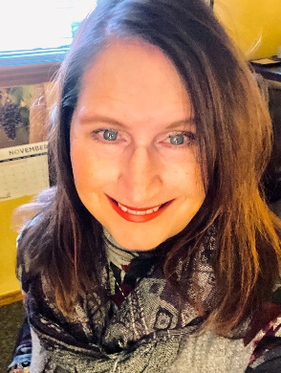
A conversation with Vernita Adolf led to two full pages of quickly scrawled notes listing a wide range of agencies and activities impacted by her energy and dedication. The basics: born in Yakima, graduating from Davis High School, attending YVCC, and obtaining a degree in small business management and entrepreneurship launched her involvement in projects and programs meeting needs throughout the area.
Beginning with People for People, Vernita worked as the Volunteer Driver Coordinator/Ombudsman and first client service representative for Yakima County's Dial-A-Ride Program. She was then hired by United Way as the Director of the Yakima Volunteer and Resource Center. Her experiences with United Way were invaluable, learning more about her community as a participant/graduate of Leadership Yakima, which then led her to working for other great agencies such as Catholic Family and Child Services, OIC of Washington and Southeast Yakima Community Center. Vernita was instrumental in the early stages of Yakima County 211 and has served on many boards including Rod’s House Homeless Youth Shelter, RSVP of Yakima County, Yakima Farmers Market, Directors of Volunteers in Agencies, YWCA and the Literacy Coalition.
Vernita's education and experience prepared her to establish her own business, VGA Professional Services, which specializes in Non-Emergent Medical Transportation driver training such as Defensive Driving and Passenger Assistance and Safety. Vernita then Founded Protran East, a non-profit agency providing Non-Emergent Medical Transportation Services to those who are low income, elderly and/or do not have access to affordable transportation. After nine years in business, Vernita, a dedicated multi-tasker, started another business, Tasteful Travels Winery and Brewery Tours. The current shutdowns due to COVID has put this business on hold, but she looks forward to restarting small group tasting tours soon.
Vernita has been married for 23 years to Alan Adolf; they enjoy 3 daughters and 11 grandchildren.
You can hear the excitement when she talks about her passion for encouraging young people to find and use their voices by being educated and involved in their community. She sees the need for youth, especially young women, to know the issues and understand what is going on. Vernita appreciates that the League of Women Voters is a non-partisan model of strong women working together to educate citizens and promote voting, and she is happy to be a new member.

MARIA CUEVAS COMMITTED TO GIVING BACK
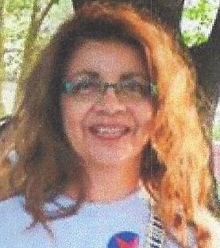
The life experiences of Maria Cuevas have spanned academia and acti-vism. A third-generation American of Mexican descent, or Chicana, Maria was born in California. A self-described “nerd,” Maria thrives in higher education. She was both student and employee at UCLA, earning Masters Degrees in Public Health and Social Welfare.
Maria came to understand that her family’s middle-class status gave her advantages that were not available to other Latin@s. She also recognizes her success as a result of the social and political policy changes fought for by the
Continued on Page 4

The Voter, December, 2020 Page 4

MARIA CUEVAS Continued from Page 3

Civil Rights Movement, Chicano Movement and Women’s Movement. Maria speaks passionately of her responsibility to “give back to the community.” She notes that her concept of “her community” includes the many people marginalized by differences of race, citizenship, poverty, gender, ability, sexual orientation, and other circumstances. Her work is to enrich communities, address inequalities, and to assist in the creation and support of equitable laws and policies.
Maria moved to Pullman, Washington in 1995 and worked toward a doctoral degree in the WSU Department of Sociology. She has completed all work except the dissertation which focuses on Chicanas and activism in the Pacific Northwest. Stimulated by her desire to work with Rosalinda Guillen, a key organizer with the United Farm Workers (UFW) in Washington state, she moved to Yakima in 2002 to work with the UFW as a liaison to apple growers with the goal of creating a fair trade apple. Subsequently, Maria was recruited to Yakima Valley College to re-design the Chican@¹ Studies Program and continues to teach at YVC.
When asked about her additional interests, Maria explains her position at YVC is “her pleasure and her work.” Working with students on issues of the Chican@ community and civic engagement, many of her graduates are currently working in policy, education, and advocacy work. This is one of the rewards of teaching new generations of students working to create stronger, equitable communities. In addition, she serves on the board of local community organizations including the Memorial Foundation and the South Central Washington Federation of Democratic Women. She also serves on the board of Community to Community (C2C), a women-led grassroots organization dedicated to food sovereignty and immigrant rights in Bellingham, WA, led by executive director, Rosalinda Guillen.
Maria lives in Yakima and enjoys time with family and friends, and exploring nature with her dog. She is pleased to join the community of women leaders in the League.

¹Designates both Chicana and Chicano, women and men

Appreciation, and a Chance to Serve…

THANK YOU, ELAINE SMITH!

For at least 5 years Elaine has managed and communicated to the Friends of League email list of (currently) 210 contacts. She asked to retire from that responsibility and the list now resides in our League Gmail account. The Voter and other announcements are sent to that group and Elaine was always good about checking if a membership email announcement or flyer should go out to the “Friends.”
We believe it serves our interest to help the larger community understand our purpose and activities. Criss will send The Voter and other information for the time being, but is looking for someone to assume that responsibility. It is an online activity only, and requires someone who will be able to promptly send out The Voter and other announcements. Don’t be shy if you think this might be something you can do for our local League, Criss would love to hear from you.
Thanks again, Elaine!

The Voter, December, 2020 Page 5

New address for Kathy Lambert, long-time active member and good friend…

Kathy and husband Jack are now living in a condo in North Seattle, close to daughter Rebecca and Kathy’s sister Judy. They have their little dog Hawkeye with them, and are doing well. Their address is 17233 15th Avenue NE, #V114, Shoreline, WA 98155.

Reflection from our National League…

APPRECIATING OUR SUCCESSES

2020 has been an undeniably difficult and stressful year, not least of all in the political realm. The following excerpts from a LWVUS message may remind us to pause and appreciate that, in spite of it all, voters have been empowered and democracy has been defended!
The 2020 elections saw the greatest voter participation in more than century…
Our award-winning nonpartisan election site VOTE411 helped more than 6 million users find the information they needed to cast their ballots…
Dedicated election administrators and volunteers ran successful elections under trying circumstances…
We thank the dedicated secretaries of state, our legal partners who fought to expand and protect voting rights, and all the election workers and postal service workers who ensured voters could make their voices heard…
One hundred years since women won the right to vote, Americans have elected the first female vice president… (While the League never endorses candidates or parties, we celebrate the election of a women to the vice presidency, because we cannot deny the historic significance of this moment.)

League of Women Voters of Yakima County…

GLANCING BACK AT 2020
This look back at the unusual year that has been 2020 does not catalog all of our activities, but it is a sampling that represents our commitment and identifies some of our individual and collective efforts. We can all be proud of who we are and what we do as a local League.
– Susan Kaphammer, Editor

January 18 – Partner and participate with Women’s March on Yakima, the opportunity for those who continue to seek justice, fairness and safety to march side by side, knowing that we are stronger together.

January 20 – Offer voter registration at the 35th Annual Martin Luther King Jr. Peace Walk and Program,

February 3 – Homeless Study Committee dedicates their work and study to Ellie Lambert, “whose enthusiasm and insight set us on the right path at the very beginning of our journey. Her caring for those who are experiencing homelessness and knowledge of their experiences gave us the courage to seek answers to our questions.”

The Voter, December, 2020 Page 6

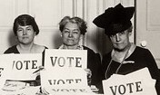

February 4 – Receive Yakima City Council Proclamation acknowledging the 100th Anniversary of the League of Women Voters (February 14, to be exact) as well as the 100th Anniversary of ratification of the 19th Amendment, granting women the right to vote!

February 25 – Sponsor League Conversation on Recycling: Global and Local.

*** And then… the coronavirus pandemic led to social restrictions.
Many events were canceled, but we found ways to adjust and continue our mission***

April 6 – Move Leadership Team monthly meetings to Zoom.
May 11 – Promote participation in Census 2020 with a street banner across Yakima Avenue.

May 29 – June 7 – Attend sessions of Centennial Council of League of Women Voters of Washington, via Zoom.

June 15 – Hold LWVYC Annual Meeting, via Zoom. Cynthia Garrick and Marilyn Shearer retire from the Leadership Team while Lee Murdock and Anita Monoian are newly elected to our Leadership Team.

July – Leadership Team member Quinn Dalan establishes an LWVYC Instagram account and manages our Facebook page; check them out at https://www.facebook.com/LWVYC/ and https://www.instagram.com/lwv_yc/

August 25 – Sponsor League Conversation with informative session via Zoom on Washington State’s New Long Term Care Act.

October – Distribute 900 English language and 600 Spanish language Voter Information flyers at health clinics, a couple of (socially distanced!) community events, and electronically through schools to about 1600 families.
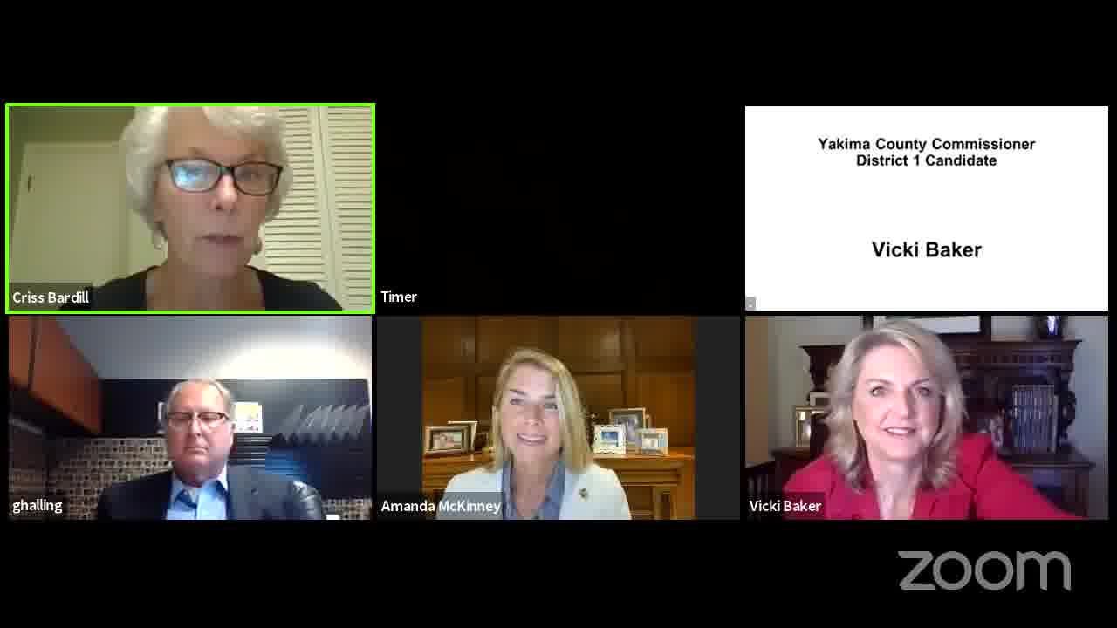

October 8 – Present Forum of County Commissioner Candidates via Zoom, live-streamed and re-broadcast by YPAC and offered on our Facebook page, which tallied 650 views and over 60 comments.

October 19 – Begin 500 personal phone contacts with newly registered voters to help Get Out the Vote.

October 27 – Sponsor League Conversation with report of Designated Crisis Responder partnership with local law enforcement.

December – Dori Peralta Baker participates in multi-session training for Speak Up School, the State and Local League initiative to prepare citizens to testify to the Washington State Redistricting Commission in 2021.

The Voter, December, 2020 Page 7

Washington State Health Tool…

“WA NOTIFY” CAN ALERT YOU TO COVID-19 EXPOSURE

Putting an app on your cell phone can let you know if you have a possible exposure to Covid-19. This lets you quickly get the care you need and helps you avoid spreading the virus to people around you. The Washington State Department of Health offers the free service and encourages its use.
With WA Notify, your phone exchanges anonymous, random codes with phones of people you are around, without revealing any information about you. A person with WA Notify who later tests positive for Covid-19 is provided a verification code for the app on his or her phone. This triggers notification to others with WA Notify who have been nearby – within 6 feet for 15 minutes or more – in the last two weeks. This anonymous notice of possible exposure includes links to information about local testing and treatment. The notice also informs you about keeping yourself and those close to you safe.

To set up WA Notify on your phone:

On an iPhone, enable Exposure Notifications in Settings:
- Go to Settings
- Scroll down to Exposure Notifications
- Click “Turn On Exposure Notifications”
- Select United States
- Select Washington

On an Android phone:
- Go to the Google Play Store
- Download the WA Notify app

The information in this article and additional details are available on the website: https://www.doh.wa.gov/Emergencies/COVID19/WANotify
We may feel “done” with this virus, but Covid-19 is not yet done with us. As of mid-December, over 1.45 million people have enabled WA Notify on their phones, and the more who use it in any community, the more effective it is. If you have not yet done so, consider adding this tool, along with masks and social distancing, to help us all make it through to the end of this pandemic.

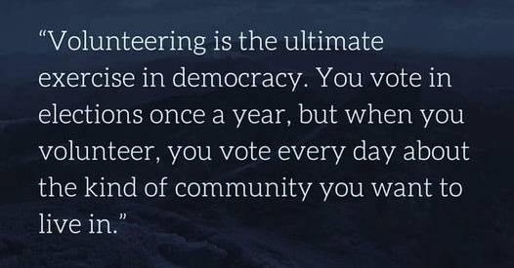

Author Unknown

The Voter, December, 2020 Page 8

LEAGUE OF WOMEN VOTERS OF WASHINGTON
STATEMENT ON DIVERSITY

The League of Women Voters is an organization fully committed to diversity, equity, and inclusion in principle and in practice. Diversity, equity, and inclusion are central to the organization’s current and future success in engaging all individuals, households, communities, and policy makers in creating a more perfect democracy. We will actively work to remove barriers to full participation in this organization on the basis of gender, gender identity, ethnicity, race, native or indigenous origin, age, generation, sexual orientation, culture, religion, belief system, marital status, parental status, socioeconomic status, language, accent, ability status, mental health, educational level or background, geography, nationality, work style, work experience, job role function, thinking style, personality type, physical appearance, political perspective or affiliation and/or any other characteristic that can be identified as recognizing or illustrating diversity

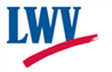

LEAGUE OF WOMEN VOTERS
OF YAKIMA COUNTY
Empowering Voters. Defending Democracy.

Name:________________________________________________________________________
Address_______________________________________________________________________

Phone Numbers:
Home___________________Work__________________Cell__________________

Email_______________________________________________
Membership Categories:

_______$60 Basic*

_______$40 Each additional family member at the same residence

_______$10 Student Associate

Sustaining Gift: $60 _____ $40 _____ $25 _____ Other:_______ Your Sustaining gift will help support our local activities.
*Please Note Dues Distribution: National: $32
Make checks payable to: LWVYC Mail to: PO Box 723
YAKIMA WA 98907

State: 19
LWVYC retains: 9
$60

