THE OTER

V

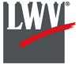

This Newsletter published by and for the

League of Women Voters of Yakima County

PO Box 723, Yakima, WA 98907 509-452-3419

*We respectfully acknowledge that we are on the traditional land of the Yakama People.*

July, 2021

Vol.21, No 7

**MISSION STATEMENT:**

Empowering Voters. Defending Democracy.

**VISION:**

We envision a democracy

where every person has the desire,

the right, the knowledge, and the confidence

to participate.

**VALUE STATEMENT:**

The League believes in the power of women to create a more perfect democracy.

**CALENDAR**

Saturday, July 24, 7:00 PM **Ellie Lambert Celebration of Life and Dance** at Selah Civic Center.

Tuesday, July 27, 5:30 PM **Community Conversation: Sex Trafficking in Yakima County** with Debra Brockman, Program Manager for Aspen Victim Services. View live or stream on LWVYC Facebook page. *See announcement below.*

Monday, August 2, 4:30 PM **Leadership Team Meeting** IN-PERSON!at the YWCA, 818 W Yakima Ave.

***Looking Ahead:***

Tuesday, August 24, 5:30 PM **Community Conversation: Opioid Epidemic in Yakima County.** Panel Discussion including Theresa Adkinson, Triumph Treatment; Sheriff Robert Udell, Yakima County; Erika Ochoa, Yakima Health District.*See notice on p. 3.*

March 26

+-

**Officers**

*President:*  Cheri Kilty

*Secretary:* Karen Pilon

*Treasurer:* Janis Luvaas

*Membership:* Rhonda Hauff

**Leadership Team**

Criss Bardill

Quinn Dalan

Kitty Jubran

Susan Kaphammer

Lee Murdock

*Voter Editor:* Susan Kaphammer

949-0127; susanlkap@gmail.com

The Board currently meets at 4:30 PM

the 1st Monday of each month

at the YWCA, 818 W Yakima Ave.

**All members are welcome.**

*Community Conversation…*

**Sex Trafficking**

**in Yakima County**

With **Debbie Brockman,**

Program Manager, Aspen Victim Services

**Tuesday, July 27, 2021**

**5:30 PM**

Watch live or stream later on the LWVYC Facebook Page

*League Conversations:*

*Informing the public on topics of interest.*

*Page 2*



**co**

***The Voter,*** April*, 2021 Page 2*

***The Voter,*** July 2021 Page 2

***Leadership Team…***

**NEW PRESIDENT CONVENES LEADERSHIP TEAM**

Cheri Kilty, elected president at our General Membership Meeting in May, led the Leadership Team at it’s July 5 meeting. After the many months of virtual meetings, the team is happy to be meeting in-person again. Members are always invited to attend Leadership Team meetings, usually held at 4:30 PM the first Monday of the month. The YWCA is hosting us in a comfortable conference room. Check the Calendar on Page 1 of this and each month’s *The Voter* to confirm the date, time and place.

The Team discussed our *Study of Homelessness in Yakima County*. The Leadership Team recommends wide-spread distribution of this document with access to read and download from our Facebook page. Copies are also to be printed and distributed through the Homeless Network, the Homeless Coalition, elected officials and public libraries in the county. The team will continue working toward clear articulation of our consensus position to guide education and advocacy activities on the issues.

The primary election is drawing near – deadline for returning ballots is August 3, 2021. Candidates will be contacted and encouraged to submit information to VOTE411 (https://www. vote411.org/). *See article on p. 3 and the attached checklist to share with family and friends.*

The League intends to conduct candidate forums prior to the general election in November, with plans to collaborate with other organizations representing various communities and constituents, including Asian Pacific Island Coalition, NAACP, Latino Community Fund, and perhaps others. The Yakima Herald-Republic was a good partner in last year’s Forum. Stay tuned for more information.

Criss Bardill spoke of the rich programs of the State League Convention. The 5-plus days of sessions provided information and inspiration, as well as calls to action in line with the theme, “The Next 100 Years Defending Democracy.” *See article on Election Credibility on p. 3*.

***LWVYC Project…***

*August Community Conversation…*

**Opioid Epidemic in**

**Yakima County**

**Tuesday, August 24, 2021, 5:30 PM**

**Online Event**

Join the conversation with a panel of community leaders including:

**Theresa Adkison**, Triumph Treatment

Yakima County **Sheriff Robert Udell**

**Erika Ochoa**, Yakima Health District

Watch live or stream later on the LWVYC Facebook Page

*League Conversations:*

*Informing the public on topics of interest.*

**MONTHLY COMMUNITY CONVERSATIONS INFORM THE PUBLIC**

The July and August events in our Yakima County League series of Community Conversations are highlighted on page 1 and to the right in this issue of *The Voter.*

The Conversations address issues of interest to members and to the larger community. Recent topics have included discrimination, policing, health issues, and more. Sessions usually include time for Q and A with the speaker or panel

Thank you to Quinn Dalan, League Leadership Team Member, who coordinates our Community Conversations. Contact her with your comments and ideas for future topics at <quinndalan@gmail.com>.

***The Voter,*** July 2021Page 3

***Defending Democracy…***

**PRIMARY ELECTION IS AUGUST 3**

You should have already received your primary election ballot by mail. With no federal or state races with primary contests, Yakima County ballots have few contested races. County residents in District 3 may select between two Republicans to advance to the County Commissioner race in the general election. And there are scattered city council and school board races in certain districts of Yakima and Selah.

Every election, no matter how limited the ballot, is important for maintaining democracy. Local races for county, city, and school board positions impact us as individuals and our communities. Will school board members support the teaching of scientific inquiry and critical thinking? Will county and city governments respond to the facts and needs revealed in our *Study of Homelessness?* These and many other issues depend upon our votes!

LWV of Washington President Lunell Haught and Voter Services Chair Mary Coltrane remind us the deadline to register online is JULY 26. They ask League members to be sure friends and family are aware, and to share the Checklist for August 3rd Primary Election (*attached to this issue)* with five contacts, asking them to do the same.

***State League Voter Services Project…***

**LEAGUE TO SUPPORT ELECTION CREDIBILITY**

In a statewide project to combat election mis- and dis- information, county auditors are being surveyed to gather accurate information about elections in Washington. The auditors will be asked about:

* their voting process
* what stories they have heard about voting credibility, voter fraud
* how they deal with duplicate names, with name changes to verify accuracy
* concerns about physical security of personnel, of ballots
* how League can help increase voter credibility
* whether there are particular demographics that we need to try to reach out to, and
* whether we’ve missed asking anything the auditor wants to tell the League about voting in their county.

Yakima County is not immune from attacks on election credibility. In local letters to the editor and casual conversations we come across opinions presented as facts and rare occurrences taken to prove widespread events, as well as distortions, misrepresentations and flat-out “un-truths.” Linea Hirst is chairing the LWVWA Election Credibility Project to gather and distribute facts about our elections. For further information or to help out contact her at [lwvquilter@comcast.net](mailto:lwvquilter@comcast.net).

You can find “[Talking Points: Combating Anti-Voter State Legislature Bills](https://www.lwv.org/league-management/talking-points-templates/talking-points-combating-anti-voter-state-legislature)” on the national LWV website: <https://www.lwv.org/league-management/talking-points-templates/talking-points-combating-anti-voter-state-legislature>. We are reminded of our responsibility:

*False narratives about the election continue to spread and require countering with trusted, factual information that does not repeat the falsehoods…* *We combat mis and disinformation by getting ahead of any falsehoods and flooding the public and voters with trusted information that builds confidence about voting and in our elections. We can get ahead of bad messaging by inoculating with good information. As much as possible, spread the right message widely before false accusations can be made.*

***The Voter,*** July 2021Page 4

***New Member Spotlight…***

**BRIANA TAMAKI WORKS TO EMPOWER WOMEN**

Briana Tamaki is a Japanese- and Filipina-American, born and raised in Yakima. She attended Davis High School and the University of Washington in Seattle and graduated with a Bachelor's in business with a concentration in human resources management. She left Amazon and the corporate world to pursue nonprofit activities.

Briana’s volunteer roles have focused on causes related to empowering women, especially sexual harassment survivors, and supporting diversity and inclusion efforts. She currently serves as the Executive Director for the Blaine & Preciosa Tamaki Foundation. The Co-Chairs, Blaine and Preciosa Tamaki, launched their Foundation publicly last year to give back to local nonprofits that promote inclusion and justice in the Yakima area and the state of Washington.

Briana recently joined the LWV, and Blaine has been a long-standing supporter of the LWV.



***League Membership…***

You would be good

for the League!

**TELL OTHERS ABOUT THE LEAGUE**

**Members join because friends encouraged their membership.**

**Members join to be part of important work.**

These statements are among the findings from interviews with 100 League members, as presented at the State Convention and recounted in July’s *This Month in the League: Monthly Updates from the LWVWA to Our Members Across the State.*

The program for this year’s State League Convention lists membership of local League chapters over the past decade. Yakima’s data indicates a high of 60 members in 2013 then a drop-off with membership at 30 for 2016-2017. But we are growing again, with an official 47 members reported in February of this year, and more added since then.

Why did you join the League (if you are already a member), or What would encourage you to join? Encouragement of friends and the opportunity to be part of important work are probably high on the list. Think of all the potential members who would welcome the chance to participate, and let’s share the message.

***LWVYC History…***

**YAKIMA COUNTY LEAGUE HISTORY FOUND**

In the move of our local League office from the now-sold Unitarian Universalist Church of Yakima to space graciously offered by the Yakima YWCA, a typed ten-page document was salvaged. “A History of the League of Women Voters of Yakima County,” indicates seven co-authors: Kara Kondo, Geneve Bowden, Marge Van Scoy, Laura Hopp, Pat Ball, Charlotte Kendrick, Marilyn Lane. The document is not dated, but the last information is for 1985.

This article will be the first of a series in this and future issues of *The Voter* to draw on this report and familiarize us with our history in Yakima County. *Editor’s Note: Direct quotes from “A History of the League…” will be indicated by quotation marks. Some details and names will be omitted*

*(Continued on Page 5)*

***The Voter,*** *July 2021 Page 5*

YAKIMA COUNTY LEAGUE HISTORY FOUND *(Continued from Page 4)*

*in these articles. At the conclusion of the newsletter series, the entire document will be made available to interested members*.

**Our Beginnings**

“On March 14, 1950, a group of women, brought together by Charlotte Kendrick, met at the Y.W.C.A. *(We come full circle! – Ed.)* for an organizational meeting to form a Provisional League of Women Voters of Yakima… A constitution and by-laws committee was formed…. At a meeting in April, the constitution was adopted. Looking for guidance in forming a new League, several members attended a workshop put on by Richland for the Yakima and Walla Walla Provisional Leagues on May 4, 1950.

“The KNOW YOUR TOWN survey of city government *(A precursor to our current They Represent Us directory?—Ed.)*… to be conducted during the summer months… was a requirement for becoming a full fledged League. We were not to drop provisional status until two years later. The first dues of $3.00 were paid at the June meeting. Charlotte Kendrick served as temporary chairman until the September 18th meeting at the Y.W.C.A.” President Ann Gilbert Ulrich (Mrs. Louis) was joined in leadership by two vice presidents, a secretary, a treasurer, three elected directors, and three appointed directors. Membership was rounded out with three additional women, for a total membership of 14.

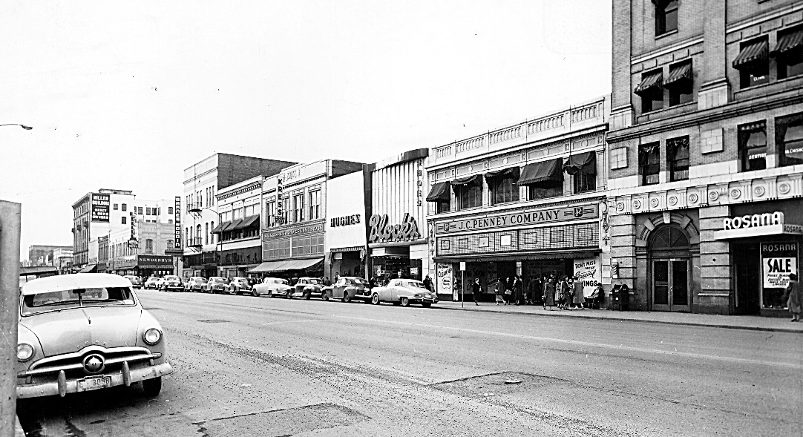 “At each meeting during our first year, two or three reports were given by members on the information gather for the KNOW YOUR TOWN study.” Meeting topics included the Fire and Police Departments and Ann Ulrich’s visit to the National Headquarters in Washington, D. C.

Downtown Yakima, 1950.

*Photo from Yakima Memory,* *an online collaboration between*[*Yakima Valley Libraries*](http://yvl.org/)*and*[*Yakima Valley Museum*](https://www.yvmuseum.org/)*.* [*https://archives.yvl.org/*](https://archives.yvl.org/)

“Plans were completed for the candidates meeting, October 16, *(Our first candidates’ forum – Ed.)* and the *distribution* of questionnaires, provided by the State League, to each candidate in October. The third Monday of each month was chosen for the regular general membership meeting night. In addition, an executive board meeting was held monthly for board assignments and future plans.

The State Organization Chair spoke “on the subject, ‘The League of Women Voters and You.’ She encouraged individual members, but not board members, to be active in the party of their choice as well as in the League. We do not support candidates, but we do study issues of concern to both major political parties. The state study items were: juvenile protection, KNOW YOUR STATE study, constitutional revision and the state tax structure.”

The first Annual Meeting held on April 16, 1951, at the Yakima Valley Junior College featured election of officers. Laura Hopp (Mrs. Blaine) became president. The first vice president was also Historian and Program Chair; the second vice president was also Finance Drive Chair. Most of the three elected and 7 appointed board members also carried assignments such as Action, Unit Organization, Publications, Public Relations, Bulletin, Membership, Voters Service, and Librarian. It was noted that “Mrs. Marilyn Longbottom Lane filled out the term for Mrs. Ann Ingham (date with the stork).”

***The Voter,*** *July, 2021 Page 6*

**LEAGUE OF WOMEN VOTERS OF WASHINGTON**

**STATEMENT ON DIVERSITY**

The League of Women Voters is an organization fully committed to diversity, equity, and inclusion in principle and in practice. Diversity, equity, and inclusion are central to the organization’s current and future success in engaging all individuals, households, communities, and policy makers in creating a more perfect democracy.We will actively work to remove barriers to full participation in this organization on the basis of gender, gender identity, ethnicity, race, native or indigenous origin, age, generation, sexual orientation, culture, religion, belief system, marital status, parental status, socioeconomic status, language, accent, ability status, mental health, educational level or background, geography, nationality, work style, work experience, job role function, thinking style, personality type, physical appearance, political perspective or affiliation and/or any other characteristic that can be identified as recognizing or illustrating diversity

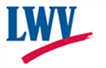

**LEAGUE OF WOMEN VOTERS**

**OF YAKIMA COUNTY**

**Empowering Voters. Defending Democracy.**

**Cordially invites you to:  JOIN US!**

Name:____________________________________________     M**embership Categories:**

Address:__________________________________________     _______$10 Student

______________________________________________________     ________$60 Basic

Phone:____________________________________________     _______$40 Each

                                                                          Additional Family

Member at the Same

E-Mail: ___________________________________________      Reside

Scholarships are available for potential members who cannot afford dues. Please contact us at [yakimacountylwvyc@gmail.com](mailto:yakimacountylwvyc@gmail.com)

Additional Sustaining Gift:  $60_______ $40 _____ $25 _____ Other:_______

Your Sustaining Gift will help support our local activities.

**Make checks payable to:** LWVYC **And mail to:** LWVYC, PO Box 723, YAKIMA WA 98907

Please note: Our fiscal year is July 1 – June 30. Initial dues received before December 31 will be subject to renewal on June 30 of the following year. Initial dues received after January 1 will be subject to renewal on June 30 of the year following that year.

Examples: a) Initial dues paid October 10, 2020; renewal date June 30, 2021

               b) Initial dues paid February 24, 2021; renewal date June 30, 2022

