THE OTER

V



This Newsletter published by and for the

League of Women Voters of Yakima County

PO Box 723, Yakima, WA 98907 509-452-3419

*We respectfully acknowledge that we are on the traditional land of the Yakama People.*

June, 2021

Vol.21, No 6

**MISSION STATEMENT:**

Empowering Voters. Defending Democracy.

**VISION:**

We envision a democracy

where every person has the desire,

the right, the knowledge, and the confidence

to participate.

**VALUE STATEMENT:**

The League believes in the power of women to create a more perfect democracy.

**CALENDAR**

Monday, July 5, 4:30 PM **Leadership Team Meeting** IN-PERSON!at the YWCA, 818 W Yakima Ave.

Saturday, July 24, 7:00 PM **Ellie Lambert Celebration of Life and Dance** at Selah Civic Center. *See notice on p. 3.*

Tuesday, July 27, 5:30 PM **Community Conversation: Sex Trafficking in Yakima County** with Debra Brockman, Program Manager for Aspen Victim Services. Via Zoom or stream on LWVYC Facebook page. *See announcement below.*

***Looking Ahead:***

Tuesday, August 24, 5:30 PM **Community Conversation: Opioid Epidemic in Yakima County.** Panel Discussion including Theresa Adkinson, Triumph Treatment, Sheriff Robert Udell, Yakima Co. Sheriff’s Office, Erika Ochoa, Yakima Health District.*See notice on p. 3.*

March 26

+-

**Officers**

*President:*  Cheri Kilty

*Secretary:* Karen Pilon

*Treasurer:* Janis Luvaas

*Membership:* Rhonda Hauff

**Leadership Team**

Criss Bardill

Quinn Dalan

Kitty Jubran

Susan Kaphammer

Lee Murdock

*Voter Editor:* Susan Kaphammer

949-0127; susanlkap@gmail.com

The Board currently meets at 4:30 PM

the 1st Monday of each month

at the YWCA, 818 W Yakima Ave.

**All members are welcome.**

*Community Conversation…*

**Sex Trafficking**

**in Yakima County**

With **Debbie Brockman,**

Program Manager, Aspen Victim Services

**Tuesday, July 27, 2021**

**5:30 PM**

Join at Zoom Link (information forthcoming)

Or Watch Live on the LWVYC Facebook Page

*League Conversations:*

*Informing the public on topics of interest.*

*Page 2*



**co**

***The Voter,*** April*, 2021 Page 2*

***The Voter,*** June 2021 Page 2

***LWVYC President’s Column…***

**NOTES FROM CHERI!**

I am thrilled to be able to work with everyone in our Yakima League. In my professional life

with the YWCA in the many communities I have served, the League of Women Voters has always been a partner working to empower our community to be involved with local issues and working to reduce barriers to full civic engagement. The partnership between our two organizations has been long and I look forward to many years to come.

The League of Women Voters state convention is coming up at the end of June. The theme is **The Next Hundred Years: Defending Democracy**. I look forward to sharing information next month.

In July, please join us for our community conversation about Sex Trafficking. This is a serious issue in our community. I hear stories everyday of women being trafficked. In August we will talk about the Opioid Crisis.

We also will be following up on our Homeless Study with our consensus statement and sharing that with the community.

A busy summer ahead. I look forward to hearing from you and having you actively involved in our conversations.

– Cheri Kilty

***LWVYC Annual Meeting…***

**IMPORTANT BUSINESS CONDUCTED AT MEETING**

On Monday, May 24th, League members gathered in person and via Zoom at the clubhouse at Windcrest Villa for our Annual Meeting. There were about 20 in-person attendees and about 7 members participated on Zoom.  The Treasurer’s report was reviewed and the proposed 2021-2022 budget was passed. The Membership Report shows that as of the meeting, we stood at 49 members!

A major portion of the meeting involved discussion of the *Study of Homelessness in Yakima County.* See the separate article on Page 3.

Officers and Leadership Team members were accepted unanimously as submitted by the Nominating Committee. Cheri Kilty will assume the position of President. Our immediate past-president, Criss Bardill, was elected to serve on the Leadership Team. Additional Team members elected to another term are Quinn Dalan, Kitty Jubran, and Susan Kaphammer, who will also continue as *Voter* editor. All positions are for two-year terms.

Continuing to serve the second year of their current terms are Karen Pilon, Secretary, Janis Luvaas, Treasurer, Rhonda Hauff, Membership Chair, and Lee Murdock, Leadership Team.

While some of the positions have shifted, all of these Leadership Team members have worked for some time to adjust the activities of our organization to the restrictions of the pandemic. A big thank you for accepting continuing responsibility in keeping the League of Women Voters of Yakima County an impactful organization in our community.

Heartfelt appreciation to Kathy Lambert. Now living on the Westside, she has been a longtime “worker bee” and leader for us, including recent time on the Leadership Team. Her many contributions have made a difference. Kathy, you will be missed. Thank you, and we wish you well!

***The Voter,*** June 2021Page 3



*August Community Conversation…*

**Opioid Epidemic in**

**Yakima County**

**Tuesday, August 24, 2021, 5:30 PM**

**Online Event**

Join us as we hear from a panel of community leaders. Panel members include:

Theresa Adkison, Triumph Treatment

Yakima Co. Sheriff Robert Udell

Erika Ochoa, Yakima Health District

Watch Live on the LWVYC Facebook Page

*League Conversations:*

*Informing the public on topics of interest.*

***Celebrating a Good Life…***

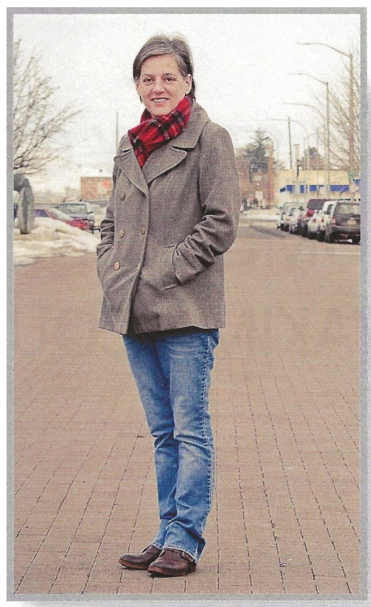

**ELLIE LAMBERT**

Message from Ellie’s sister:

Celebration of Life & Selah Civic Center Dance for Ellie Lambert

Saturday, July 24th, 7:00pm

at Selah Civic Center(duh)

*It’s been a long time since we’ve had a chance to gather but we’re finally ready! Please come help celebrate the life of my amazing sister. Food, drinks and fun! Wear your dancing shoes! She wanted a celebration!*

***LWVYC Study of Homelessness in Yakima County…***

**MOVING TOWARD CONSENSUS POSITION**

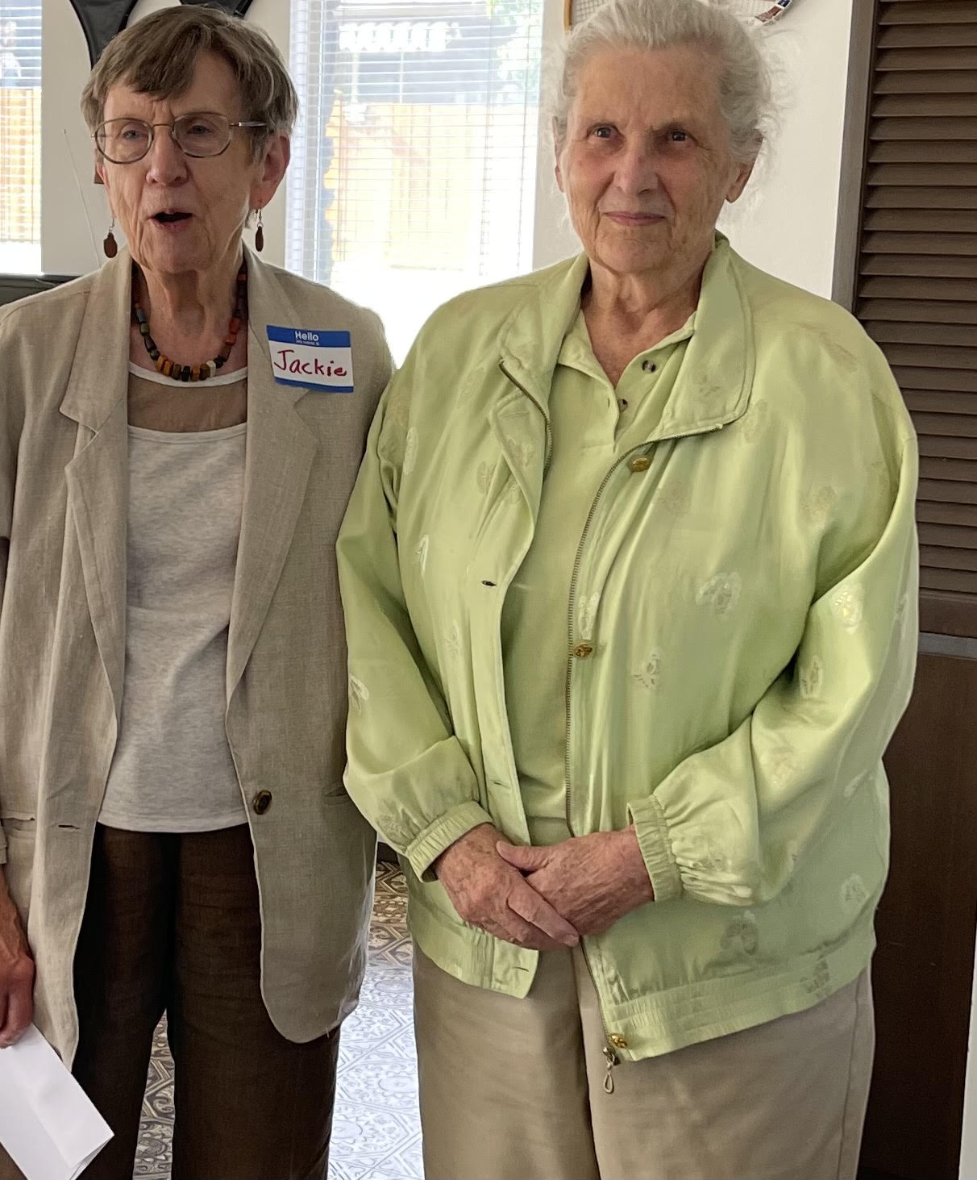At the Annual Meeting in May, members considered the *Study of Homelessness in Yakima County*. This report documents the findings from the three-year effort to describe causes, identify services, assess the adequacy of services, and examine the roles of various government and non-governmental agencies.

An engaging and invigorating discussion of the report was prompted by questions delving into gaps in services and resources, the balance between emergency services and permanent housing, provision of public restrooms for unsheltered residents, community understanding of homelessness as a social and health care issue rather than a crime, and support for evidence-based practices. Comments from this discussion will help inform the Leadership Team’s work on a Consensus Position that will require member approval and then guide activism on this important issue.

*Jackie Hertel recognized for leadership on Study Committee.*

Jackie Hertel was heralded as the Study Committee leader from the very beginning “through thick and thin.” Members applauded the entire committee, which also included Betty Van Ryder, Carrie Huie-Pascua, Ellie Lambert, Jackie Call, Marilyn Shearer, and Mary Stephenson. Ellie Lambert, to whom the report is dedicated, was lauded for her enthusiasm and insight. Lee Murdock was thanked for her careful work in updating data, proofing the report and publishing the study.

**LEAGUE OF WOMEN VOTERS OF WASHINGTON STATEMENT ON DIVERSITY**

The League of Women Voters is an organization fully committed to diversity, equity, and inclusion in principle and in practice. Diversity, equity, and inclusion are central to the organization’s current and future success in engaging all individuals, households, communities, and policy makers in creating a more perfect democracy.We will actively work to remove barriers to full participation in this organization on the basis of gender, gender identity, ethnicity, race, native or indigenous origin, age, generation, sexual orientation, culture, religion, belief system, marital status, parental status, socioeconomic status, language, accent, ability status, mental health, educational level or background, geography, nationality, work style, work experience, job role function, thinking style, personality type, physical appearance, political perspective or affiliation and/or any other characteristic that can be identified as recognizing or illustrating diversity.

***The Voter,*** June 2021Page 4

***New Member Spotlight…***

**BECKY ROWE INTRODUCES HERSELF**

I was raised in Toppenish on a ranch and I am still there.  Careers that I have had include real estate, home inspector for FEMA and Allstate.  One summer I was a mule skinner for Conestoga Tours in Toppenish. One winter I enjoyed cooking Sunday lunch for the community food bank. I am currently self-employed.

I have a particular interest in homelessness and the environment and am looking forward to participating in the League of Women Voters.

*Welcome, Becky. How interesting… real estate to mule skinner! We look forward to getting to know you; it is good to have you with us. SK, Editor.*



**LEAGUE OF WOMEN VOTERS**

**OF YAKIMA COUNTY**

**Empowering Voters. Defending Democracy.**

**Cordially invites you to:  JOIN US!**

Name:____________________________________________     M**embership Categories:**

Address:__________________________________________     _______$10 Student

______________________________________________________     ________$60 Basic

Phone:____________________________________________     _______$40 Each

                                                                          Additional Family

Member at the Same

E-Mail: ___________________________________________      Reside

Scholarships are available for potential members who cannot afford dues. Please contact us at [yakimacountylwvyc@gmail.com](mailto:yakimacountylwvyc@gmail.com)

Additional Sustaining Gift:  $60_______ $40 _____ $25 _____ Other:_______

Your Sustaining Gift will help support our local activities.

**Make checks payable to:** LWVYC **And mail to:** LWVYC, PO Box 723, YAKIMA WA 98907

Please note: Our fiscal year is July 1 – June 30. Initial dues received before December 31 will be subject to renewal on June 30 of the following year. Initial dues received after January 1 will be subject to renewal on June 30 of the year following that year.

Examples: a) Initial dues paid October 10, 2020; renewal date June 30, 2021

               b) Initial dues paid February 24, 2021; renewal date June 30, 2022